Torque Master Boost Actuator Kit Patrol 3.0Ltr

Please take your time installing this kit
The motor must be cold before installation begins.

Tools
- 10mm spanner
- Hook tool
- 8mm drill bit
- 1/8 bsp tap
- Tread sealant
- 7mm socket and 12mm

Part 1.
Pull the silicone hose off and move it out of the way (we won’t be using this pipe anymore)
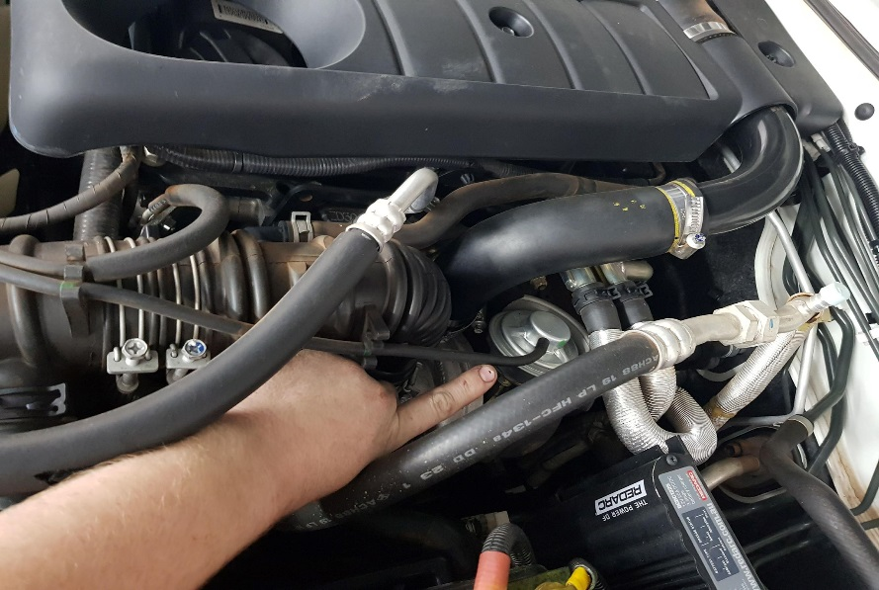
Part 2.
Cut the factory vacuum line back
Zip tie the factory line closed so nothing can be sucked into it
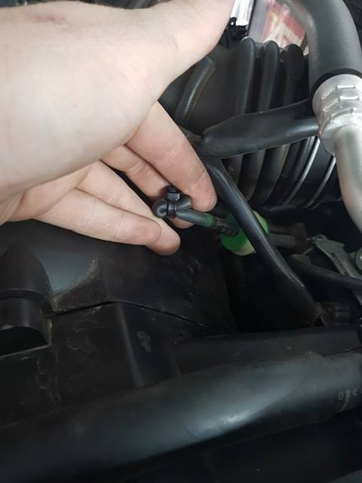

Part 3.
Undo the 2 10mm nuts
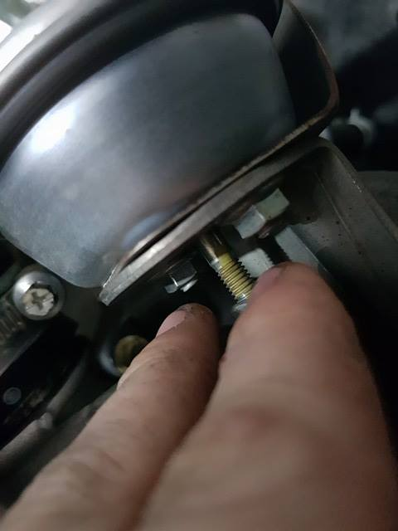
Remove the circlip with the hook tool or a tool you find easy to use to do this task
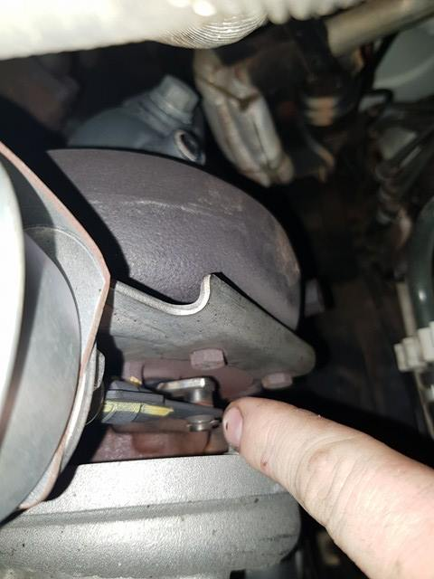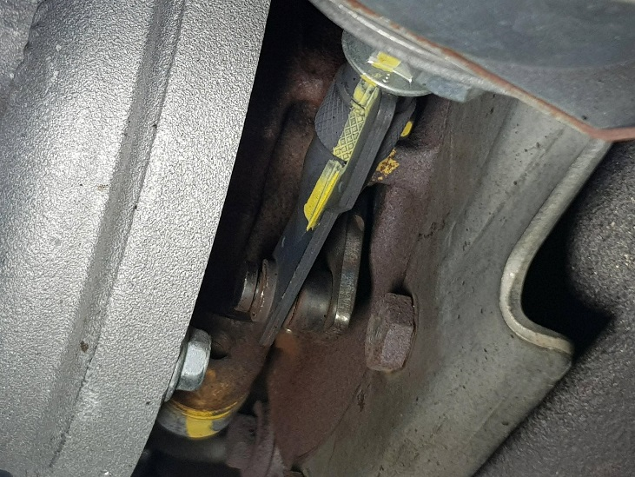

Part 4.
Pull the actuator up and forward to get it out
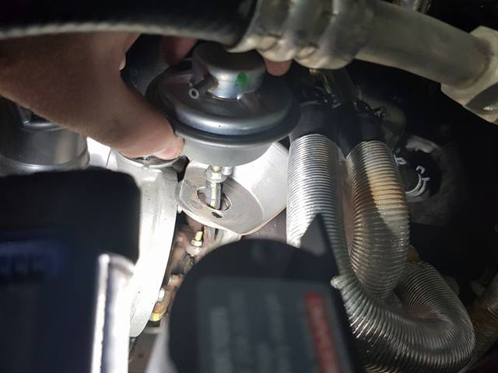

Part 5.
Remove the engine cover
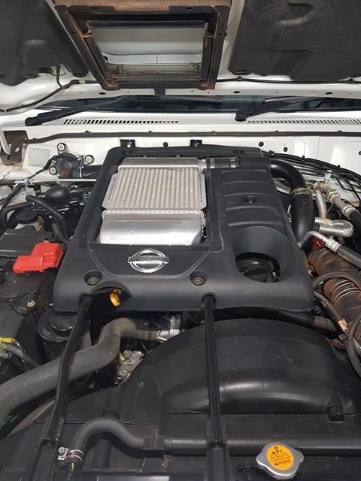
Remove the intercooler
4x 12mm bolts
2x 7mm hose clamps
Carefully unplug the map sensor
If using the boost adaptor unbolt the map sensor and put it in between the intercooler and map sensor
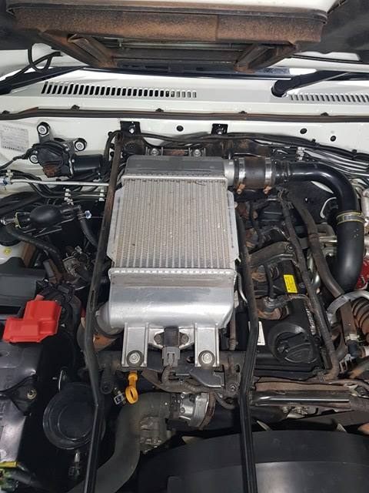
Part 6.
Drill into the intercooler with the 8mm
Please drill in the same place as shown
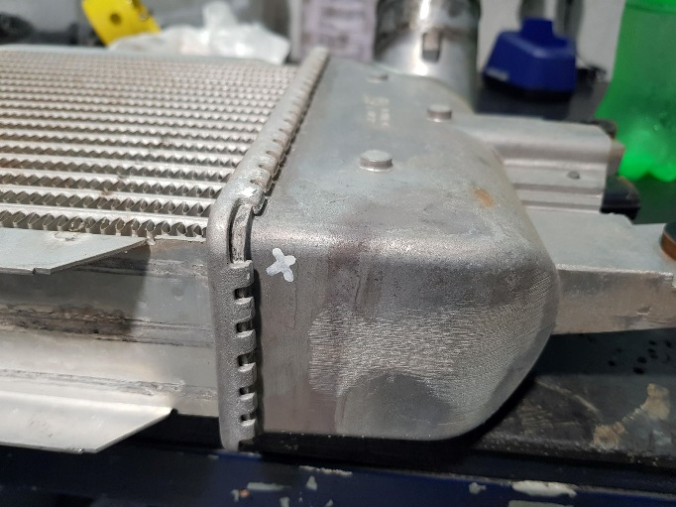
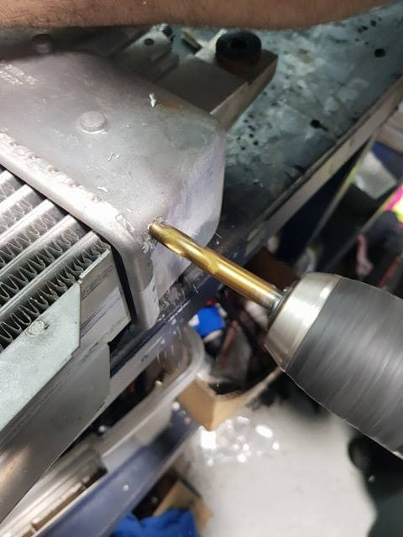

Part 7.
Tap with the 1/8 BSP tap into the area shown in the photo on the intercooler
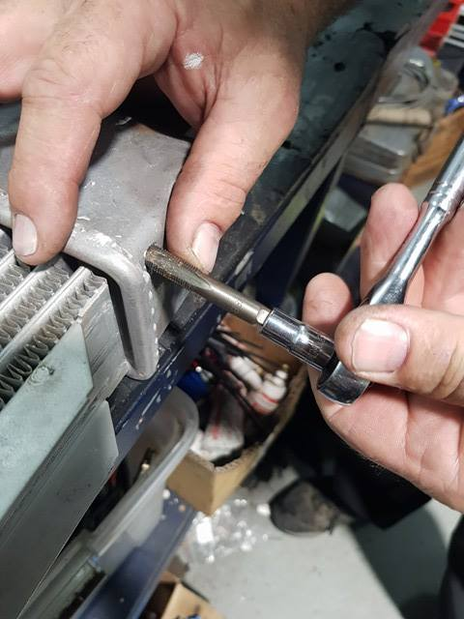
Put tread sealant onto brass fitting and fit it into the intercooler 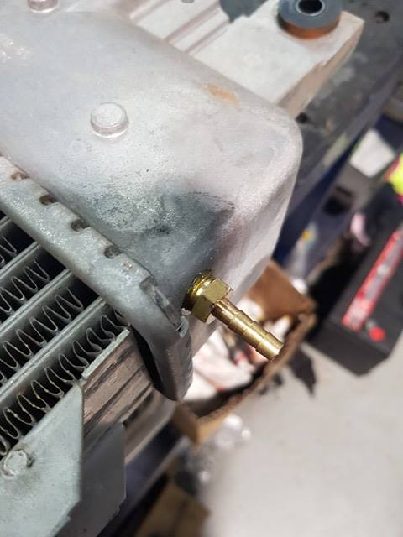

Part 8.
Clean the intercooler pipe where the intercooler goes
Also clean the intercooler ends to make sure that you remove all the oil residue off
NOT DOING THIS CORRECTLY CAN AND WILL BLOW THE INTERCOOLER HOSE OFF 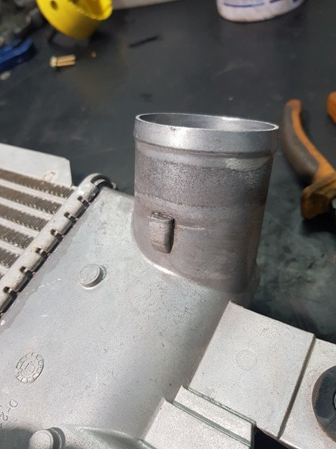 Like this please
Part 9.
Get the Torque Master Actuator and fit the tail on the end of the shaft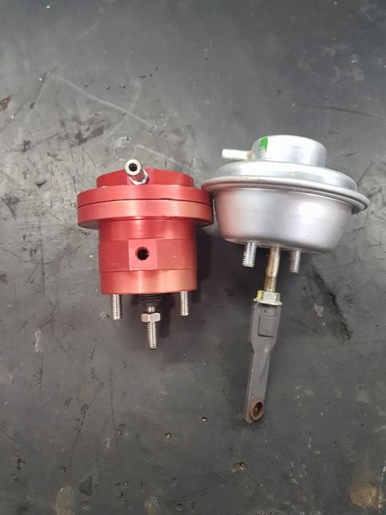 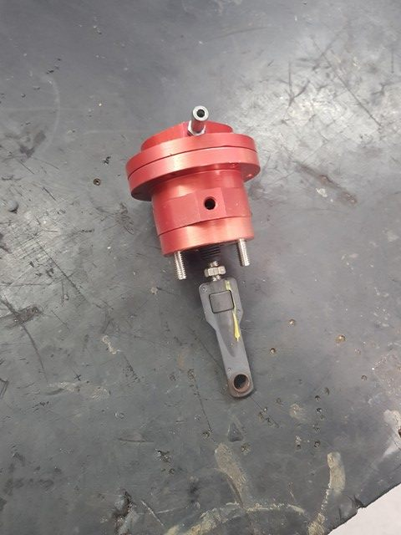
Part 10.
Fit the actuator onto the factory bracket on the turbo
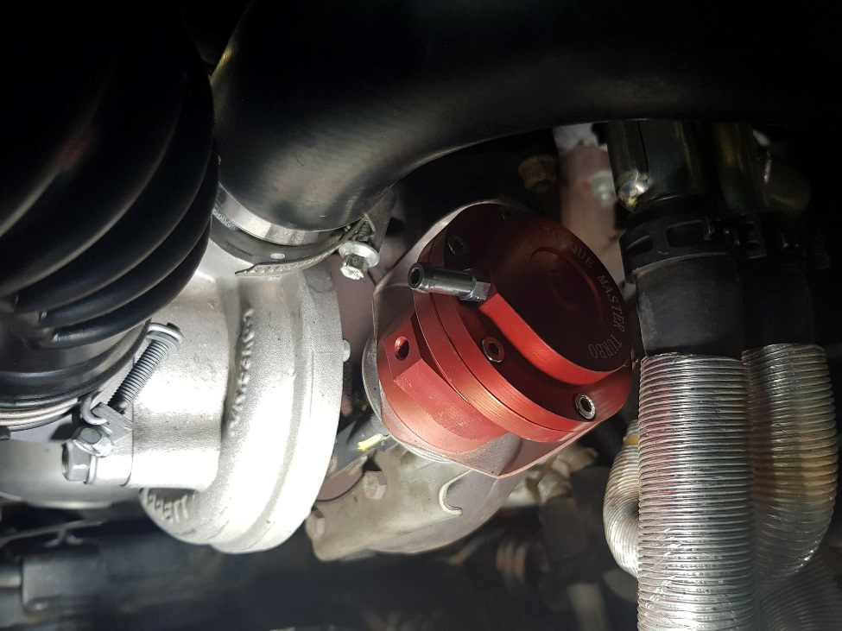
Put the new 10mm nuts on the bottom and do up tight
Once Nuts are tight screw the tail all the way up on the VNT arm on the turbo until it hits the starter/stopper screw
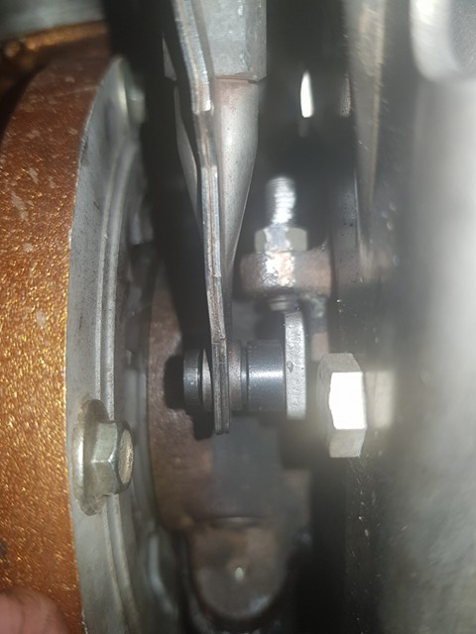
Part 11.
Tighten the lock nut to the top of the tail to stop it from moving

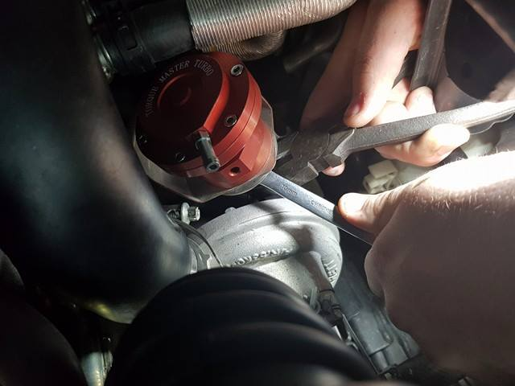

Part 12.
Fit the intercooler back onto the car
Part 13.
Fit the silicone hose from the intercooler to the Torque Master Actuator. ZIP TIE BOTH ENDS
Boost line should have nothing T’d into it like a boost gauge
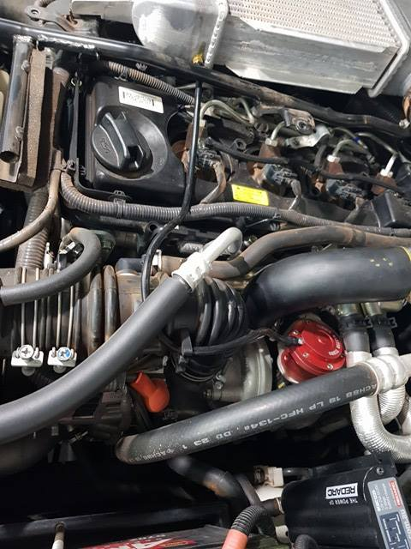

Part 14.
Refit the Engine Cover

You are all done now
Please test drive slowly and let it come on boost slowly
Once you are happy with everything go for a good drive

Troubleshooting?

- Laggy to come on Boost: Check to make sure the Tail is all the way up and tight

- Boost spiking: have you got a boost gauge or something else T’d into the silicone for the actuator

Any questions please call

(07) 49530040

Facebook
Diesel Smart Performance Products

www.dieselsmart.com.au

Thanks For your Business

